BLESSING MAKARABA
10 Oladipupo Oduwole Street,
Ojodu Berger
Lagos

DOB: 4th July, 1996

Bank Verification Number (BVN): 22260224790

Mobile: 08167672019
E-mail: blessingmakaraba@gmail.com

Career Objectives: A detailed-oriented Full Stack JavaScript Engineer with prowess in computational techniques, algorithms; possessed with the ability to excel in a fast-paced environment and adapt readily to new challenges, Equipped with these arts, my aim is to contribute to the resolution of problems within any sector.

Education

2017 Delta State University Delta State
B.Sc in Mathematics
First Class

2012 Damasia College Delta State
SSCE

Employment Record :( detailing all career progression during the period)

Date | Grade | Position | Organization
July 2019 – September 2019 |  | JavaScript Engineer | Andela
November 2017-October 2018 |  | Executive Assistant | Osun State College of Education, Ilesa
August 2012-November 2012 |  | Computer Operator | Milliab Services, Warri

Work Experience: sequential order

July 2019 – September 2019

Full Stack JavaScript/PREN Engineer

Andela

Key responsibility: Worked in a distributed team of six (6) software engineers in building a product (BareFoot Nomad) using Agile Software Development Methodologies.

Key Accomplishment in your last 3 roles: sequential order

November 2017-October 2018

Executive Assistant

Osun State College of Education, Ilesa

Key Accomplishment: Managed the day-to-day operations of the office of the Head of Department. Organized and maintained files and records, and planned and scheduled meetings, and appointments.

August 2012-November 2012

Computer Operator

Milliab Services, Warri

Key Accomplishment: Monitored and controlled electronic computer and peripheral electronic data processing equipment to process business, engineering and other data according to customer’s instruction

Professional Qualification
2018 | Post-Graduate Diploma in Project Management |  Student   Affiliate  √ Member   Fellow

Management Training

Year | Programme name | Institution | Location

Languages

Language name |  Excellent |  Good |  Fair
English | √

Skills

Skills |  Excellent |  Good |  Fair
Analytic Skills |  | √
Communication (Oral & Written) | √
Data entry(word-processing/spreadsheet/graphics) |  | √
Excellent IT and numeracy skills | √
Problem Solving | √
Programming | √
Resilience, Tenacity and Integrity | √
Decision Making |  | √
Data Analysis |  | √
Team Work | √
Critical thinking | √
Solve-complex problems | √
Strategic Planning | √
Team Building | √
Forecasting Skills |  | √

Interest and activities

Engaging in creative discourse
DevOps
Playing Chess

References

Name | Position | Address | Telephone
Gift Abobo | HR officer | 10 Oladipupo Oduwole, Ojodu Berger | 07069659979
Kingsley Ehis Ekoh-Ordan | Software Dev | 1A Awori Str., Dolphin Estate, Ikoyi | 08073019950

Certification:
I, the undersigned, certify that to the best of my knowledge and belief, these data correctly describes me, my qualifications and my experience.

____________________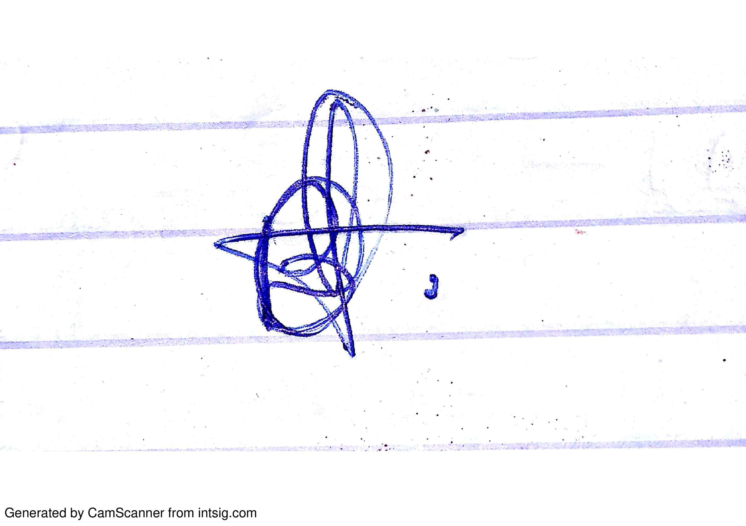___________________________________________
Signature

